# Analytic Functions - Basic

## Task 01: Create Ad Hoc SQL FIRST_VALUE, LAST_VALUE

FIRST LAST VALUE shows beginning and end of the “window”.

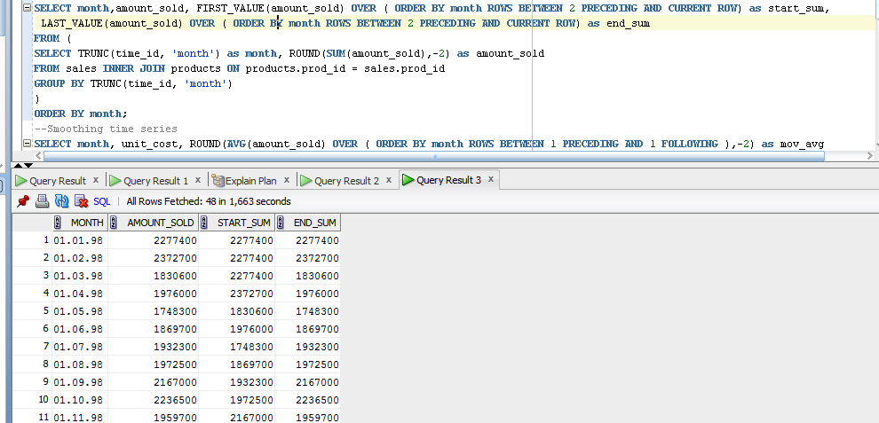

*Dense_Rank First* give the earliest rows, *min* select min value in this rows.

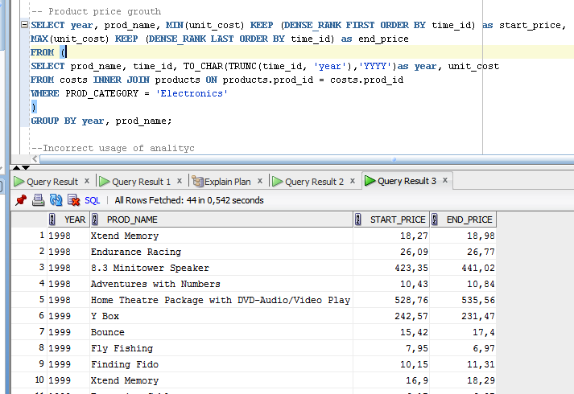

## Task 02: Create Ad Hoc SQL RANK, DENSE_RANK, ROWNUM

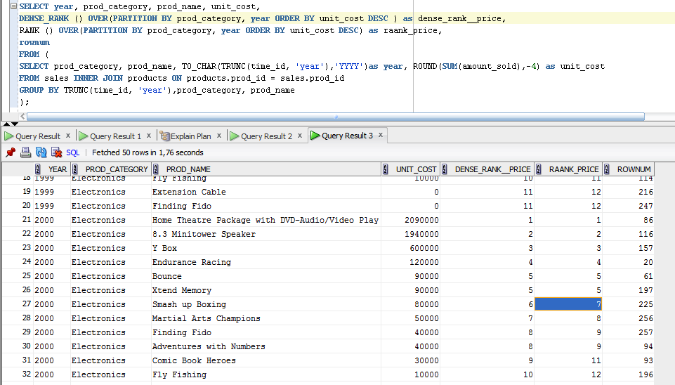

*Dense_rank* keep all serial numbers, *rank* skip values after similar rows, rownum don’t change according the ORDER BY clause

## Task 03: Create Ad Hoc SQL AGGREAGATE FUNCS

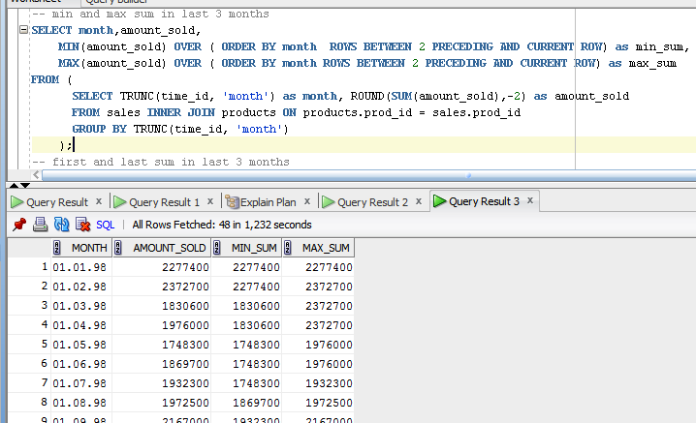

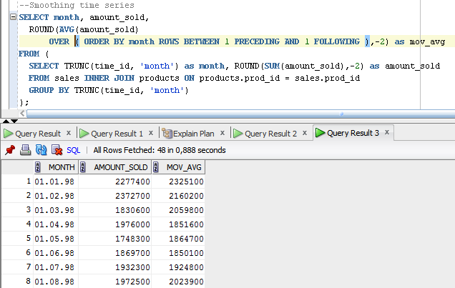

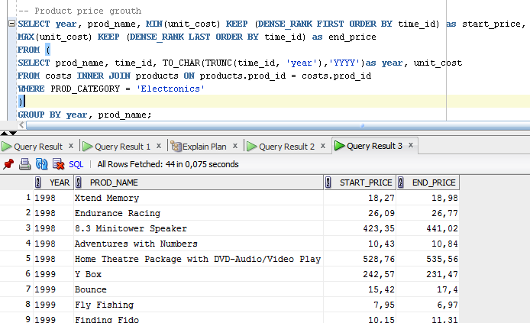

**P.S.**

Two queries, returning the same sets. But usage of the analytical function with unbounded window is not effective. Because of such a window.

